Write a program that prompts the user to enter three characters. Use the predefined character function isLetterOrDigit to check if the entered characters are alphanumeric (A-Z, a-z, or 0-9). Finally, print the result values separated by a newline.
Sample Output 1
Enter the first character: 1
Enter the second character: a
Enter the third character: b
true
true
true
Sample Output 2
Enter the first character: 5
Enter the second character: `
Enter the third character: d
true
false
true
Sample Output 3
Enter the first character: `
Enter the second character: '
Enter the third character: /
false
false
false

Write a program that prompts the user to enter two strings and a character. The program should then perform a character search in each string and concatenate the substrings that contain the searched character using the predefined string functions. Finally, it should display the concatenated result.
Sample Output 1
Enter the first string: helloworld
Enter the second string: worldhello
Enter character to search: world
worldworldhello
Sample Output 2
Enter the first string: happyeveryday
Enter the second string: everyoneishappy
Enter character to search: eve
everydayeveryoneishappy
Sample Output 3
Enter the first string: computation
Enter the second string: computer
Enter character to search: comp
computationcomputer

Create a program that asks the user to enter a number between -1 and 1. Use the predefined math function to calculate and print the arc sine (inverse sine) of the number.
Sample Output 1
Enter a number between -1 and 1: 0.43
The arc sine of 0.43 is: 0.44
Sample Output 2
Enter a number between -1 and 1: 0.55
The arc sine of 0.55 is: 0.58
Sample Output 3
Enter a number between -1 and 1: 0.11
The arc sine of 0.11 is: 0.11

Write a program that takes two inputs: an int age and an int hasDriverLicense. It should determine whether a person is eligible to drive based on the following rules and print the corresponding eligibility message:
- If age is greater than or equal to 16 and hasDriverLicense is 1, print "Eligible to drive"
- If age is greater than or equal to 16 but hasDriverLicense is 0, print "Apply for a driver's license"
- If age is less than 16, print "Not eligible to drive"
Sample Output 1
Enter your age: 16
Do you have a driver's license?: 1
Eligible to drive
Sample Output 2
Enter your age: 16
Do you have a driver's license?: 0
Apply for a driver's license
Sample Output 3
Enter your age: 15
Do you have a driver's license?: 1
Not eligible to drive

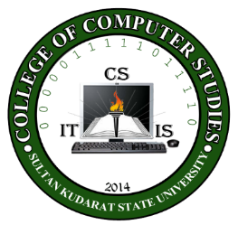
Republic of the Philippines

SULTAN KUDARAT STATE UNIVERSITY
Isulan, Sultan Kudarat
College of Computer Studies
S.Y. 2018-2019

UNIVERSITY VISION

A trailblazer in arts, science and technology in the region.

UNIVERSITY MISSION

The University shall primarily provide advance instruction and professional training in science and technology, agriculture, fisheries, education and other related field of study. It shall undertake research and extension services, and provide progressive leadership in its area of specialization.

UNIVERSITY GOAL
To produce graduates with excellence and dignity in arts, science and technology.

UNIVERSITY OBJECTIVES
- Enhance competency development, commitment, professionalism, unity and true spirit of service for public accountability, transparency and delivery of quality services;
- Provide relevant programs and professional trainings that will respond to the development needs of the region;
- Strengthen local and international collaborations and partnerships for borderless programs;
- Develop a research culture among faculty and students;
- Develop and promote environmentally-sound and market-driven knowledge and technologies at par with international standards;
- Promote research-based information and technologies for sustainable development;
- Enhance resource generation and mobilization to sustain financial viability of the university.

Program Objectives and its relationship to University Objectives:
PROGRAM OBJECTIVES (PO) | UNIVERSITY OBJECTIVES
A graduate of BS in Computer Science can:
A graduate of BS in Computer Science can: | a | b | c | d | e | f | g
- Design and implement effectively the innovative computing research; | / | / |  | / | / | / | /
- Apply proficiently the algorithm theories and related computational system in conducting research; | / | / | / | / | / | / | /
- Address societal problems through producing sustainable research output; and | / | / | / | / | / | / | /
- Demonstrate professionalism in the social environmental and legal aspects of computer science. | / | / | / | / | / | / | /

5. Course Description:

This course provides an in-depth study of the fundamental concepts in automata theory and formal languages. The course covers finite automata, regular expressions, context-free grammars, pushdown automata, Turing machines, and related topics. It also delves into the decidability and complexity of computational problems, equipping students with the theoretical foundation necessary for advanced studies in computer science.

1. Course Code : ALT 312
2. Course Title : Automata Theory and Formal Language
3. Prerequisite : PL 222
4. Credits : 3 UNITS

6. Course Learning Outcomes and Relationships to Program Objectives

Course Learning Outcomes | Program Objectives
At the end of the semester, the students can: | a | b | c | d | e
- Understand the fundamental concepts of automata theory and formal languages. | / | / | / | / | /
- Analyze and design finite automata, regular expressions, and context-free grammars. | / | / | / | / | /
- Explore the power and limitations of different computational models like pushdown automata and Turing machines. | / | / | / | / | /
- Study the concepts of decidability, undecidability, and computational complexity. | / | / | / | / | /
- Apply theoretical concepts to real-world problems and computational tasks. | / | / | / | / | /

7. Course Content

Course Objectives, Topics, Time Allotment | Desired Student Learning Outcomes | Outcomes-Based Assessment (OBA) Activities | Evidence of Outcomes | Course Learning Outcomes | Program Objectives | Values Integration
1. Topic: SKSU VMGO, Classroom Policies, Course Overview, Course Requirements, Grading System (2 hour)
1. Discuss the VMGO of the university, classroom policies, scope of the course, course requirements and grading system | 1.1 Student can be aware of and appreciate of the university’s VMGO, classroom policies, course overview, requirements and grading system. | Individual participation in class discussion and group presentation | Group and individual discussions |  |  | Value of appreciation
Week 1: Introduction to Automata Theory and Formal Languages
- Overview of automata, formal languages, and computation.
- Historical context and significance.
Week 2: Finite Automata: Deterministic and Non-deterministic
- Deterministic Finite Automata (DFA).
- Non-deterministic Finite Automata (NFA).
- Equivalence of DFA and NFA.
Week 3: Regular Expressions and Regular Languages
- Regular expressions and their equivalence to finite automata.
- Properties of regular languages.
- Pumping lemma for regular languages.
Week 4: Context-Free Grammars (CFG) and Context-Free Languages
- Introduction to context-free grammars.
- Derivations, parse trees, and ambiguity.
- Properties of context-free languages.
Week 5: Pushdown Automata (PDA)
- Definition and operation of pushdown automata.
- Relationship between PDA and context-free languages.
- Deterministic vs. non-deterministic PDA.
Total number of hours with laboratory (36 hours)

Lectures 36 hours
Laboratory
Examination 4 hours

8. Course Evaluation

Course Requirements : 80% running program

Grading System:
MID-TERM and FINAL-TERM
Participation/Attendance 10%
Assignment 5%
Quiz 15%
Seatwork/lab exercises 20%
Exam 50%

Schedule of Examination:

Midterm Final Term
Classes End

References:

Textbooks:

Introduction to Automata Theory, Languages, and Computation 3rd Edition

An Introduction to Formal Languages and Automata, 5th Edition 5th Edition

Introduction to Automata Theory, Formal Languages and Computation 1st Edition, Kindle Edition

Automata Theory and Formal Languages (Express Learning)

K.V.N. Sunitha, Formal Languages and Automata Theory
- John Carroll, Darrell D. E. Long, Theory of Finite Automata with an Introduction to Formal Languages

Introduction to the Theory of Computation 3rd Edition

A Second Course in Formal Languages and Automata Theory

Laxmi Publications, Theory of Automata and Formal Languages

Introduction to Computer Theory 2nd Edition

Supplemental:
- https://www.tutorialspoint.com/automata_theory/index.htm
- https://www.javatpoint.com/automata-tutorial
- https://www.geeksforgeeks.org/theory-of-computation-automata-tutorials/
- https://www.ics.uci.edu/~goodrich/teach/cs162/notes/
- https://www.udemy.com/course/theory-of-automata/

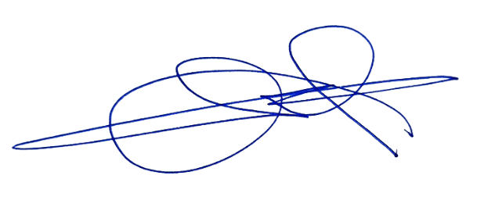

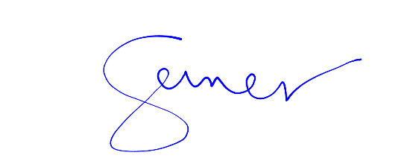
Prepared by: Reviewed by:

CYRUS B. RAEL CECILIA E. GENER, MIT
Faculty Program Head, BSCS

Approved by:

CECILIA E. GENER, MIT
Dean, College of Computer Studies

